Chapter 3

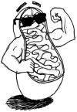
Respiration:
Unicellular organisms take Oxygen directly from the surrounding media
Multi-cellular organisms have a specialized respiratory system
Carbon dioxide is produced from respiration
Gas exchange is to obtain Oxygen instead of Carbon dioxide or vice versa
Cellular respiration is the breaking down of food molecules in order to release energy

Cellular Respiration:
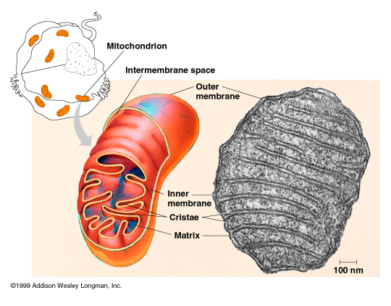
It is the process by which energy is extracted from bonds of the food (produced by plants and consumed by others
Carbohydrates are forms of storing energy (and transport energy between cells and between living organisms)
Glucose is a carbohydrate that is used commonly by the majority of living organisms
Energy needed by a cell can be provided as ATP (Adenosine tri phosphate), In cellular reactions usually one of three bonds of phosphate is broken to convert it to ADP and release 7-12 K cal
C₆H₁₂O₆ + 6 O₂ 6CO₂ + 6H₂O + 38 ATP
Oxidation of Glucose takes place in 3 stages:
Glycolysis: Occurs in the non organ part of cytoplasm (cytosole)
Krebs cycle and electron transport: occurs in the mitochondria, because it the organelle contains respiratory enzymes, water, phosphate groups, co-enzymes and electron carrier or cytochromes.
ATP  ADP  ATP  ADP  4 ADP+4P  4 ATP  2NAD⁺  2NADH | Glucose | 6C
 | Glucose 6-phosphate | 6C
 | Fractose 6 phosphate | 6C
 | Fructose 1-6 phosphate | 6C
 | 2 phosphoglysraldhyde (PGAL) | 3C
 | 2 Pyrovic acid | 3C
 | Either aerobic or an aerobic respiration
Hydrogen atoms are removed from the carbon skeleton of glucose and pass to co enzymes which act as hydrogen carriers such as NAD and FAD
Examples of reduction reactions:
NAD⁺ + H₂NADH + H⁺
FAD + H₂ FADH₂

Glycolysis:
- Takes place in both aerobic and anaerobic respiration
- One molecule of glucose breaks down forming 2 molecules of pyruvic acid
- Detailed steps are illustrated I the chart
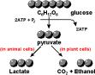
- In case of anaerobic respiration (absence of Oxygen) 2 pyrovic will produce 2 lactic acid (in muscles) or produce 2 ethyl alcohol (in Yeast) .
- $C_{6}H_{12}O_{6}\underset{→}{Anaerobic respiration \left(respiratory enzymes\right)} 2C_{3}H_{4}O_{3}+2ATP$
- In case of aerobic respiration it will enter the Krebs cycle then electron transport.

Krebs cycle:
Fats

Fatty acid
Proteins

Amino acid
CO₂
2 acetyle co-A (2C)

1- Each molecule of acetyl group produces 2 CO₂, 3 NADH, 1 ATP and one FADH₂ (It means that Krebs cycle is repeated twice)
NAD NADH
FAD FADH₂ ADP ATP
2NAD 2NADH
CO₂
CO₂
CO-A
2- Krebs cycle does not need Oxygen because all electrons and protons are removed during oxidation of carbon atoms and received by NAD⁺ and FAD

Electron transport chain:
- At the terminal stage of aerobic respiration and by the end of krebs cycle, hydrogen and high energy electrons carried by NAD⁺ and FAD are transported by a certain sequence of co enzymes called cytochromes (electron carriers) present inside the inner membrane of mitochondria, they carry electrons at different energy levels these high energy electrons are passed from one molecule of cytochromes to another and releasing energy from ATP converting it to ADP + P group (This is why we call it oxidative phosphorylation)
 | Glucose
→ | ↓
↑ | PGAL
2 ATP | ↓ | 2 NADH | 6ATP
 | ↓ |  | 2 ATP
Pyruvic
acid
 | ↓ | 2NADH | 6ATP
 | 2C₂
Krebs cycle |  |  | 2 ATP
 |  | 6 NADH | 18 ATP
 |  | 2 FADH₂ | 4 ATP
- Oxygen is the last receptor in the electron transport chain 2e + 2 H⁺+ ¹/₂ O₂H₂O (In electron transport chain every NADH = 3ATP and every FADH₂ = 2 ATP)
- In aerobic respiration 38 ATP is produces 2 in the cytoplasm and 36 inside the mitochondria.
- Calculate the energy produced with the help of the chart

Anaerobic respiration:

- When oxygen is missing or in low quantity, living organisms as bacteria and fungi respire by another kind of respiration called anaerobic respiration.
- Also plant and animal cells may respire anaerobicaly when oxygen is not available, and this is known as fermentation, this kind of respiration does not need oxygen but it takes place in the presence of special enzymes.
- Anaerobic respiration starts the same way as aerobic respiration by the decomposition of a glucose molecule into two molecules of pyruvic acid with two molecules of NADH and a small quantity energy as 2 ATP released. Pyruvic acid is converted according to the type of cell in which it was formed, in case of animal cells, especially the muscle fibers, when the muscles exert vigorous efforts or exercises they consume most of the oxygen in their cells and tended to convert pyruvic acid into lactic acid after its reduction by combining with hydrogen on NADH $C_{6}H_{12}O_{6}\underset{→}{acidic fermintation }{2C}_{3}H_{6}O_{3}\left(Lactic acid\right)+ 2ATP$
- This is known as (muscular fatigue), (if oxygen is available, lactic acid is converted into pyruvic acid again and then into acetyl co-A) In the case of bacteria pyruvic acids converts into lactic acid. In the case of yeast or in some plant cells pyruvic acid is reduced into ethyl alcohol and carbon dioxide. This process is called alcoholic fermentation and is used in the industry of some products.
$C_{6}H_{12}O_{6}\underset{→}{Alcoholic fermintation }{2C}_{2}H_{5}{OH}_{}\left(Ethyle alcohol\right)+2 C{O }_{2}+2ATP$

Summery chart for anaerobic respiration

General Questions on Chapter 3

Complete the following:
- ………………. organisms take Oxygen directly from the surrounding media
- ……………… organisms have a specialized respiratory system
- ………………. is produced from respiration
- ……………….. is to obtain Oxygen instead of Carbon dioxide or vice versa
- ……………….. ………………….. is the breaking down of food molecules in order to release energy
- 2e + 2 H⁺+ ¹/₂ O₂…………………..
- (In electron transport chain every NADH = …………..ATP and every FADH₂ = …………… ATP
- In aerobic respiration 38 ATP is produces 2 in the cytoplasm and 36 inside the mitochondria.
- Calculate the energy produced with the help of the chart Each molecule of acetyl group produces ……….. CO₂, ………………. NADH, ………… ATP and ………….. FADH₂
- Krebs cycle is repeated ………… times
- Oxygen is the ………. receptor in the electron transport chain
- When oxygen is …………… or in ……………….. quantity, living organisms as bacteria and fungi respire by another kind of respiration called anaerobic respiration.
- NADH $C_{6}H_{12}O_{6}\underset{→}{acidic fermintation }{2C}_{3}H_{6}O_{3}\left(Lactic acid\right)+ ……………..$
- of some products.
$C_{6}H_{12}O_{6}\underset{→}{Alcoholic fermintation }………………….\left(Ethyle alcohol\right)+2 C{O }_{2}+2ATP$

Put T in front of the true statement and F in front of the false one
- circulation is the process by which energy is extracted from bonds of the food (produced by plants and consumed by others
- Carbohydrates are forms of storing energy (and transport energy between cells and between living organisms)
- Protein is a carbohydrate that is used commonly by the majority of living organisms
- Energy needed by a cell can be provided as ATP (Adenosine tri phosphate),
- In cellular reactions usually one of three bonds of ATP phosphate is broken to convert it to ADP and release 10-20 K cal
- C₆H₁₂O₆ + 6 O₂ 6CO₂ + 6H₂O + 12 ATP
- Oxidation of Glucose takes place in 3 stages
- Glycolysis: Occurs in the non organ part of cytoplasm (cytosole)
- Krebs cycle and electron transport: occurs in the mitochondria,
- Nucleus is the organelle contains respiratory enzymes, water, phosphate groups, co-enzymes and electron carrier or cytochromes.Hydrogen atoms are removed from the carbon skeleton of glucose and pass to co enzymes which act as hydrogen carriers such as NAD and FAD
- Krebs cycle Takes place in both aerobic and anaerobic respiration
- One molecule of glucose breaks down forming 3 molecules of pyruvic acid
- n case of anaerobic respiration (absence of Oxygen) 2 pyrovic will produce 2 lactic acid (in muscles) or produce 2 ethyl alcohol (in Yeast) .
- $C_{6}H_{12}O_{6}\underset{→}{Anaerobic respiration \left(respiratory enzymes\right)} 2C_{3}H_{4}O_{3}+2ATP$

Complete the following chart

 | Name of substance | No of Carbon atoms
ATP  ADP  ATP  ADP  4 ADP+4P  4 ATP  2NAD⁺  2NADH | Glucose
 |  | 6C
 | Fractose 6 phosphate
 |  | 6C
 | 2 phosphoglysraldhyde (PGAL)
 |  | 3C
 | Either aerobic or an aerobic respiration

Draw:
- detailed version of Krebs cycle
- Electron transport
- Anaerobic respiration

Give reasons for:
- Krebs cycle and electron transport: occurs in the mitochondria
- Krebs cycle does not need Oxygen
- Electron transport is called oxidative phosphorylation
- Aerobic respiration is better than anaerobic respiration
- Phosphorus is important in any energy related operation in the body
- ATP is called the energy currency of the cell.

Remember
Next period we are going to have a quiz
Every week we'll have a quiz
To maintain your place at my lesson you should score at least 90%
This is Thanawya 3ama we are working at so there is no time for anything but studying
C U Next Tuesday
Mr.Ayman Elsangary

Respiration in man

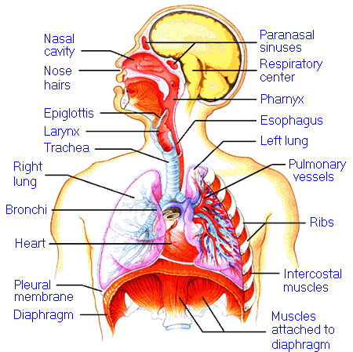
Respiratory system in man
- Air enters the body from nose or mouth, Nose is preferable because it is warm and moist (due to blood capillaries and mucus) and it also serves as a filter (due to the presence of hairs).
- Air passes through pharynx (common passage of air and food)
- Air passes to the trachea through larynx (voice box)
- Trachea wall contains ³/₄ cartilage rings which prevent trachea from collapse
- The inner surface of trachea is lined with cilia, which beats upwards tending to create air and mucus current (to impede the entry of small foreign bodies.
- Trachea is divided into two bronchi which divide and subdivide into smaller and smaller bronchioles
- Each bronchiole opens into one of many alveoli (air sac).
- Each lung has about 600 million air sac
- The thin alveolar walls are considered the actual respiratory surface as they are surrounded with a large network of blood capillaries.
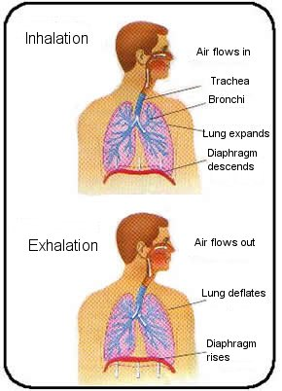
- Blood receives oxygen from the alveolar air and carries it to the rest of the body. It gives out CO₂ to the alveoli in return so that it may get rid of it.
- The whole group of alveoli and bronchioles connected to them, together with the huge network of capillaries constitute the lung. Each animal including man processes two lungs.

The mechanism of respiration in man
- The respiratory muscle is called diaphragm, Beside two groups of internal and external chest muscles that move the ribs.
- In inspiration,:
  - The internal muscles between the ribs contract
  - Ribs move up.
  - The diaphragm muscle below the lungs contracts.
  - An increase in the chest cavity which results in a reduction in the internal pressure.
  - This causes the outside air to flow from the outside through the nose and downwards through the trachea and finally into the lungs.
The opposite occurs during expiration where the ribs muscles and the diaphragm relax thus reducing the volume of the chest cavity and increasing the internal pressure. This causes the air to be forced outside the lungs.
During each respiratory cycle (inspiration and expiration), the aeration of the lungs does not usually exceed 10% of its capacity. This ratio varies according to the state of the individual between rest and exhaustion and according to the depth of inspiration.
At the end of expiration, we notice that part of the air is always left in the lungs to warm the new air coming to the lungs and prevent the adhesion of the alveoli membrane from inside. The human lungs are characterized by having a large surface area through which gas exchange occurs.
The change in the rate and depth of respiration are accompanied with similar changes in heart beats which is regulated by the centre of respiration in the brain.
The respiratory system in man plays an important role in the excretion of water. The expirated air contains water vapour. Man usually loses daily about 500 cm³ of water through his lungs out of the 2500 cm³ of water that he loses daily. This is due to the evaporation of water that moistens the alveoli membranes. This water is necessary for dissolving oxygen and carbon dioxide so that the exchange of gases between the air of the alveoli and the surrounding blood in the capillaries occurs.

Respiration in plant:
- The green plant absorbs light energy from the sun and transforms it into chemical energy through photosynthesis process to store as high energy complex organic molecules (glucose).
- The plant needs energy from respiration, in most plants each living cell is in direct contact with the external environment and therefore gaseous exchange is easy to occur. In this case oxygen gas diffuses inside while CO₂ is released outside the cell.
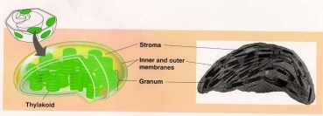
- In the case of vascular plants which are complicated in structure, oxygen reaches the cells through various passage ways.
  - When the stomata of the leaf open, air enters to the air chambers and then diffuses through the intercellular spaces spreading to various parts of the plant.
  - The gas diffuses through the cell membranes and dissolves in the water of the cell.
  - Some of the oxygen is carried to the phloem passage way, dissolved in water, and finally reaches the tissues of the stem and the root.
O₂
CO₂+H₂O
  - Oxygen may also enter the plant through the roots, soluble in water of the soil solution when it is absorbed by root hairs or imbibed by cell walls.
  - If the stem of the plant is green, the stomata which spread on its surface will act as an entrance for air.
  - Similarly, the lenticels or any cracks in the bark of woody stems may act the same.
- CO₂ resulting from respiration of the plant, is expelled to the outside by direct diffusion or from the inner cells to xylem or phloem by mutual diffusion till it reaches the stomata
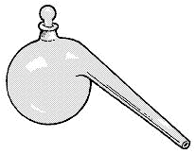
- Chloroplasts and mitochondria are reversing each other's work
2

Experiment 1: to illustrate evolution of CO₂ during aerobic respiration:

Non green parts of the plant:
No | What's in beaker1 | What's in retort2 | What will happen | Why
1 | KOH | Dry seeds | Nothing | Dry seeds don't respire
2 | NaCl | Germinated seeds | Nothing | NaCl Doesn't react with CO₂
3 | KOH | Germinated seeds | KOH gets turbid and the solution rises to the tip of the retort | CO₂ from respiration reacts with KOH and dissolve in it and because the amount of Oxygen absorbed is equal to CO₂ released the volume of gases decrease .  1

Experiment 2: Green parts of the plant
Experiment | Obs. | Conclusion | Drawing
- Put a green plant under a glass jar together with a beaker of lime water  - Put another lime water outside the jar | - Lime water turbid  - Lime water does not get turbid in the same speed. | CO₂ resulting from the green plant makes lime water turbid | 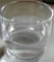  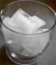

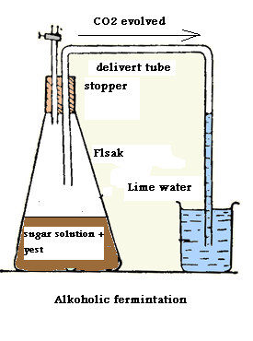
Experiment 3: Illustration of alcoholic fermentation:

Procedures:
- Prepare apparatus as the figure
- You can use molasses diluted with double of its volume water instead of sugar
- Leave it for several hours.

Observations:
Gas bubbles in the flask and lime water gets turbid

Conclusion:
Yeast respiration produces carbon dioxide
Another Kind of fermentation is acidic fermentation:
- Carried out by several kinds of bacteria.
- It produces acid instead of alcohol
- Many milk products (Cheese, butter and yoghurt) are manufactured by this kind of fermentation.
Seeds of angiosperms can respire anaerobicaly if they kept away from air.

General Questions on Chapter 3

Complete the following:
- Air enters the body from ……………. or ………………..,
- …………………. is preferable as an air entrance.
- ……………… it is warm and moist (due to blood capillaries and mucus)
- ……………….. serves as a filter (due to the presence of hairs).
- Air passes through ………………………… (common passage of air and food)
- Air passes to the trachea through …………………. (voice box)
- Trachea wall contains ………. /……….. cartilage rings which prevent trachea from collapse
- The inner surface of trachea is lined with …………, which beats upwards tending to create ………………….. and …………… current (to impede the entry of small foreign bodies.
- Trachea is divided into ……………. bronchi which divide and subdivide into smaller and smaller …………………….
- Each bronchiole opens into one of many ………………… (air sac).
- Each lung has about ……………. million air sac
- The thin ……………………. walls are considered the actual respiratory surface as they are surrounded with a large network of blood capillaries.
- Blood receives ……………….. from the alveolar air and carries it to the rest of the body. It gives out ………………… to the alveoli in return so that it may get rid of it.
- Each animal including man processes …………. lungs.

Put T or F correcting the false one:
- The respiratory muscle is called diaphragm,
- Three groups of internal and external chest muscles move the ribs.
- In inspiration the internal muscles between the ribs contract
- In inspiration ribs move down.
- In inspiration the diaphragm muscle below the lungs relax
- In inspiration An increase in the chest cavity which results in a reduction in the internal pressure
- In inspiration the outside air flow from the outside through the nose and downwards through the trachea and finally into the lungs.
- During each respiratory cycle (inspiration and expiration), the aeration of the lungs does not usually exceed 30% of its capacity.
- The previous ratio (in question 8) is constant
- At the end of expiration, we notice that part of the air is always left in the lungs to cool the new air coming to the lungs and prevent the adhesion of the alveoli membrane from inside.
- The human lungs are characterized by having a large surface area through which gas exchange occurs.
- The change in the rate and depth of respiration are accompanied with similar changes in liver beats which is regulated by the centre of heart in the brain.
- Man usually loses daily about 1500 cm³ of water through his lungs out of the 3500 cm³ of water that he loses daily.
- The green plant absorbs light energy from the sun and transforms it into heat energy through photosynthesis process to store as high energy complex organic molecules (glucose).
- In most plants each living cell is in direct contact with the external environment and therefore gaseous exchange is easy to occur.
- In the case of vascular plants which are complicated in structure, oxygen reaches the cells through respiratory system.
- When the stomata of the leaf open, air gets out from the air chambers and then diffuses through the intercellular spaces spreading to various parts of the plant.
- The gases can diffuses through the cell membranes and dissolves in the water of the cell.
- Some of the oxygen is carried to the phloem passage way, dissolved in water, and finally reaches the tissues of the stem and the root.
- Oxygen may enter the plant through the roots, soluble in water of the soil solution when it is absorbed by root hairs or imbibed by cell walls.
- If the stem of the plant is brown, the stomata which spread on its surface will act as an entrance for air.
- The lenticels or any cracks in the bark of woody stems may act the same.
- CO₂ resulting from photosynthesis of the plant, is expelled to the outside by direct diffusion or from the inner cells to xylem or phloem by mutual diffusion till it reaches the stomata
- Chloroplasts and mitochondria are having the same function.

Mention an experiment to illustrate:
- Evolution of CO₂ during aerobic respiration in
- Non green parts of the plant
- Green parts of the plant
- Alcoholic fermentation

Give reasons for:
- It is preferable to breathe through the nose not the mouth
- Nose is moist
- Nose is warm
- Nose serves as a filter
- Pharynx can be considered as a part of both digestive and respiratory systems
- Trachea dose not collapse
- Cilia of trachea beats upwards
- The thin alveolar walls are considered the respiratory surface
- part of the air is always left in the lungs
- Centre of respiration in the brain is related to heart beats
- The respiratory system in man plays an important role in the excretion of water

