Excretion in living organisms

The concept and importance of excretion:
- All biological processes that occur in the bodies of all living organisms are carried out through chemical reactions that leave some waste products.
- The living organism must get rid of these waste products as soon as they are formed, otherwise it will cause many problems and infections. The process by which the living organisms get rid of these waste products is called excretion.

First: Excretion in animals:
- The process of excretion refers only to the material that leave the body through the plasma membranes. The undigested food that goes out of the animal body in the form of faeces is not considered as excretion. The same thing applies to the nitrogen in the air which enters the lungs in inspiration and leaves them in expiration.
- The important waste products that are produced and excreted from the animal body includes CO₂ and water that are produced from organic molecules degeneration, and the nitrogenous waste products (ammonia, urea and uric acid) which results from protein degradation.
- The organs that carry out excretion in the higher animals are the skin, the lung, the liver and the kidneys.
- The excretion organs in animals regulate the body content of minerals.
- Some of the spices that have volatile content leave the body through the lungs and the rest is excreted through the kidney.
- The poisonous materials are transformed into non-poisonous forms in the body or into non-soluble form by the liver or the kidney.

Materials execrated and excretory organs:
The excretion organ | The excreted material
Lungs | Carbon dioxide
Kidneys – skin - lungs | Water
Kidneys – skin (small perling) | Nitrogenous waste products
Kidneys - skin | Salts
Kidneys – lungs (volatile substances) | Spices

Excretion in man:
The skin:
- It is considered as the largest excretion organ in man.
- It is the biggest organ in the body as it covers the whole body and the limbs from the outside.
Skin structure: The skin consists of two main layers, an outer epidermis an inner dermis. Under this is a layer of fat.

The epidermis:
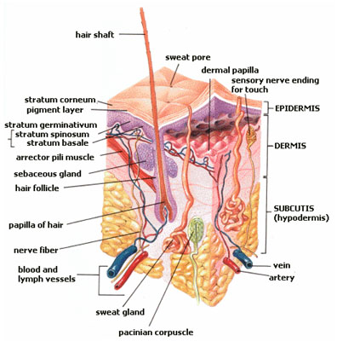
- It consists of several layers of epithelial cells.
- At the surface, the cells are dead, full of a horny substance, called keratin and always are subjected to friction, e.g. when wiping your face or body with a towel or rubbing your hands.
- This layer is worn away and is continually replaced from beneath.
- At the base of its inner layer, there are pigments cells which secrete granules responsible for the color of the skin (melanin).

2- Dermis
It is next to the epidermis, consisting of connective tissues. It contains blood capillaries, nerve endings, lymphatic, sweat glands, fat glands, fatty cells and hair follicles.

The sweat gland
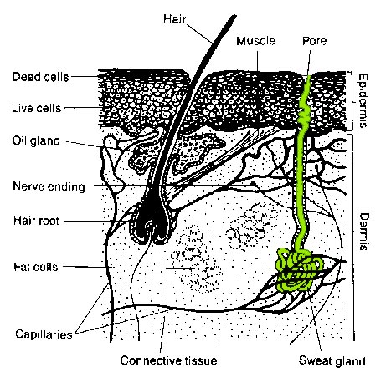
- It is a coiled tube that reaches the skin surface through a pore.
- The sweat is continually produced on the surface of the skin, so decreasing the body temperature.
- Remaining wastes causes the skin to be sticky.
- It is important to remove these wastes continually by washing; otherwise sweat pores become blocked resulting in a foul odour.

The hair
- It is made of a hair follicle, surrounded by many blood capillaries.
- At its free end, there is a sebaceous (fat) glands, which produces an oily secretion. This oil secretion facilitates the exit of the hair from the skin, keeping it soft and pliable. The hair follicle is supplied with an erector muscle.
- The sensory nerve endings respond to touch, pain and temperature.

The kidney:
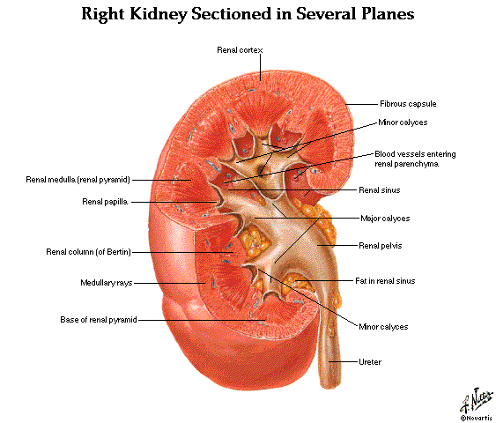
- Each vertebrate animal has two kidneys.
- In lower vertebrates, the kidneys are long, thin organs which extend from the two sides of the vertebral column.
- In higher vertebrates, such as mammals, the kidneys are more firm and are situated behind the peritoneum (membranes lining the abdominal cavity).
- A tube, called ureter, runs from each kidney to the base of the bladder, through which urine is collected and passes to the outside through the urethra.

Kidney structure:
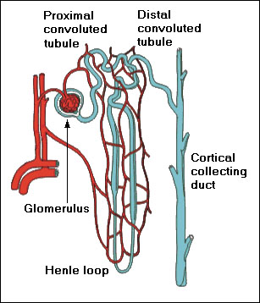
- The two kidneys are situated in the upper part of the abdominal cavity, one at each side of the vertebral column.
- The length of each kidney is about 12 cm long and about 7 cm wide. Its thickness is about 3 cm.
- The kidney is bean-shaped. Its outer part is convex, while the inner one is concave
- . On the inner side of each kidney, the renal artery comes from the aorta, and the renal vein leads to the posterior vena cava.
- Internally, the kidney is differentiated into two regions, an outer narrow cortex and an inner broad medulla.
- The functional unit of the kidney is the nephron.
- Each kidney consists of about one million nephrons each nephron starts in the cortex with a cup shaped, thin, double-walled Bowman's capsule.
- The capsule leads to:
  - The first coiled tubule in the cortex
  - Then to the loop of henle in the medulla which is U-shaped,
  - Then to the second coiled tubule in the cortex before joining the collecting duct.
  - This duct opens in the concave cavity of the kidneys called the pelvis.
  - A ureter emerges from each kidney, which passes the urine into a small muscular sac called the urinary bladder.
  - The ureter opens at the back of the bladder in an inclined position.
  - A sphincter muscle closes the outlet of the bladder till urine accumulates, then the bladder contracts expelling the urine through a duct called the urethra.

Urine extraction:
- The renal arteries come from the aorta,
- Each entering a kidney at its concave surface.
- The renal artery divides into a great many arterioles and capillaries at the cup-shaped nephron.
- Plasma (blood fluid) filters out of the blood to collect in the nephrons.
- The filtered fluid contains water, wastes. Salts and glucose, but the blood cells and large protein molecules remains in the blood.

What happens if all the content of this fluid are excreted outside the body?
In this case the body will lose much of its required water and essential substances and the individual has to drink, daily, 170 liters of water to compensate its loss, Therefore, re-absorption of required water, glucose and minerals substances, back into the blood, must take place.
The remaining liquid contains nitrogenous wastes (urea), some inorganic salts and excess water which forms the urine. Excess substances, such as small amounts of glucose and vitamins may be also present.

Re-absorption
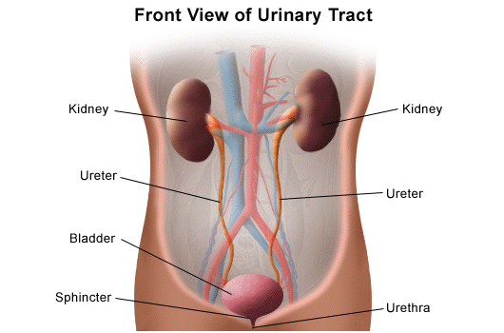
- Takes place in the nephron tubule.
- Urine then passes down the collecting duct to the pelvis of the kidney where it collects and continues down the ureter to the bladder to be stored.
- When the bladder contracts, urine is expelled through the urethra. Kidneys, ureters, urinary bladder and urethra are collectively known as "the urinary system".
- The individual can live with one kidney. In this case, this kidney grows and becomes slightly bigger to perform the function of two kidneys.
- No one can live without a kidney; nor can he live if the kidneys stop functioning. Accumulation of poisonous wastes in the blood leads to death.
- The human body contains about 5.6 liters of blood. 1.2 - 1.3 liters of blood passes through the kidney per minute,
- The total amount of blood which passes daily through the kidney is about a600 liters (i.e. approximately 1/4 of the blood volume pumped by the heart).
- This means that a very high percentage of blood always passes through the kidney to be examined about 560 times per day.

The artificial Kidney:
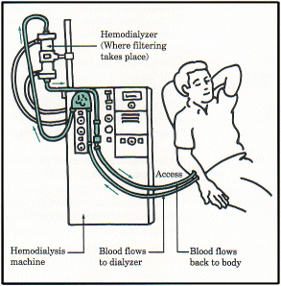
- Kidney failure takes place due to some diseases. The kidney stops functioning and this leads to the accumulation of harmful wastes in the blood.
- In treating cases of kidney failure, a tube is inserted into an artery in the patient's arm and the blood is channeled through semi permeable tube immersed in a bath containing all the normal blood chemicals except urea and other metabolic wastes.
- Since the concentration of harmful metabolic wastes is higher in the blood than in the bath, they pass through the wall of the tubes into the bath and purified blood is returned to the body. A patient receives artificial kidney treatment for several hours each day, 2 – 3 times a week.
General questions on Execretion

Answer the following questions:

Give reasons for:
- It is important to remove the wastes continually by washing.
- At the free end of the hair there is a sebaceous (fat) gland.
- Not all the content of the blood fluid are excreted outside the body
- Hair comes out easily from the skin
- The undigested food that goes out of the animal body in the form of faeces is not considered as excretion
- Nitrogen in the air which enters the lungs in inspiration and leaves them in expiration not considered as excretion.

Write short account about:
- Nephron
- Kidney
- Skin
- Sweet glands
- Hair
- Re-absorption
- Artificial kidney

Write the scientific term:
- The process that refers only to the materials which leave the body through the plasma membranes.
- Organs that excrete salts
- An organ that excrete salts and water
- It is considered as the largest excretion organ in man.
- It consists of two main layers, an outer epidermis an inner dermis.
- It is the biggest organ in the body as it covers the whole body and the limbs from the outside.
- It consists of several layers of epithelial cells.
- A horny substance at the surface, covers dead cells
- This layer is worn away and is continually replaced from beneath.
- At the base of its inner layer, they are found and secrete granules responsible for the color of the skin
- Name of the substance responsible for the color of the skin.
- It is next to the epidermis, consisting of connective tissues.
- It contains blood capillaries, nerve endings, lymphatic, sweat glands, fat glands, fatty cells and hair follicles.
- It is a coiled tube that reaches the skin surface through a pore.
- It causes the skin to be sticky.
- It is made of a hair follicle, surrounded by many blood capillaries.
- At its free end, there is a sebaceous (fat) glands, which produces an oily secretion.
- It is a secretion facilitates the exit of the hair from the skin
- Each vertebrate animal has two of it and it is responsible for urine extraction.

Put T or F
- All biological processes that occur in the bodies of all living organisms are carried out through chemical reactions that leave some waste products.
- The living organism must get rid of waste products as soon as they are formed ,
- Waste products can cause many problems and infections.
- The process by which the living organisms get rid of all waste products is called respiration
- The process of excretion refers only to the material that leave the body through the plasma membranes.
- The undigested food that goes out of the animal body in the form of faeces is considered as excretion.
- Nitrogen in the air which enters the lungs in inspiration and leaves them in expiration is an example of execretion.
- The important waste products that are produced and excreted from the animal body includes CO₂ and water that are produced from organic molecules degeneration, and the nitrogenous waste products (ammonia, urea and uric acid) which results from protein degradation.
- The organs that carry out excretion in the higher animals are only the skin, and the kidneys.
- The excretion organs in animals regulate the body content of minerals.
- Some of the spices that have volatile content leave the body through the lungs and the rest is excreted through the kidney.
- The poisonous materials are transformed into non-poisonous forms in the body or into non-soluble form by the liver or the kidney.

Complete the following table:
The excretion organ | The excreted material
 | Carbon dioxide
 | Water
 | Nitrogenous waste products
 | Salts
 | Spices

Complete
- ……………………… is considered as the largest excretion organ in man.
- …………………….. is the biggest organ in the body as it covers the whole body and the limbs from the outside.
- The skin consists of two main layers, an outer ……………….. and inner …………………...
- ……………… consists of several layers of epithelial cells.
- At the surface of epidermis the cells are ……….., full of a horny substance, called ……………. and always are subjected to …………………., e.g. when wiping your face or body with a towel or rubbing your hands.
- Epidermis is worn away and is continually replaced from …………………………….
- At the base of its inner layer, there are …………………. cells which secrete granules responsible for the color of the skin (melanin).
- …………………. is next to the epidermis, consisting of connective tissues.
- ……………………….. contains blood capillaries, nerve endings, lymphatic, sweat glands, fat glands, fatty cells and hair follicles.
- ………………………. is a coiled tube that reaches the skin surface through a pore.
- The sweat is continually produced on the surface of the skin, so …………………….. the body temperature.
- Remaining wastes causes the skin to be ……………………...
- ………………….is made of a hair follicle, surrounded by many blood capillaries.
- The hair …………………. is supplied with an erector muscle.
- The sensory ………………………… endings of the hair respond to touch, pain and temperature.
- Each vertebrate animal has ……………. kidneys.
- In …………….. Vertebrates, the kidneys are long, thin organs which extend from the two sides of the vertebral column.
- In higher vertebrates, such as ……………………., the kidneys are more firm and are situated behind the ……………………. (membranes lining the abdominal cavity).
- A tube, called ……………., runs from each kidney to the base of the bladder, through which ……… is collected and passes to the outside through the urethra.
- The two kidneys are situated in the upper part of the ……………………… cavity, one at each side of the vertebral column.
- The length of each kidney is about ………….. cm long and about ……… cm wide. Its thickness is about ……… cm.
- The kidney is ……………-shaped. Its outer part is …………………., while the inner one is concave
- . On the inner side of each kidney, the renal artery comes from the aorta, and the renal vein leads to the …………….. vena cava.
- Internally, the kidney is differentiated into two regions, an outer narrow ……………… and an inner broad ………………...
- The functional unit of the kidney is the …………………..
- Each kidney consists of about one ……………………. nephrons each nephron starts in the cortex with a …………….. shaped, thin, double-walled Bowman's capsule.
- The renal arteries come from the …………………., each entering a kidney at its concave surface.
- The renal artery divides into a great many arterioles and capillaries at the …………………………...
- ……………………. (Blood fluid) filters out of the blood to collect in the nephrons.
- The filtered fluid contains ……………………, ………………..,. ……………………. and ……………………

Answer the following:
- What happens if all the content of this fluid are excreted outside the body?
- Explain the process of re-absorption
- What is kidney failure means and how can we treat it.

Best Luck Mr. Ayman Elsangary

Excretion in plants
- The plant also utilizes the nitrogenous wastes in the synthesis of the required proteins.
- since the metabolism of plants is based mainly on carbohydrates rather than proteins, this reduces their excretory needs, as the wastes of carbohydrate metabolism are less toxic than those resulting from protein metabolism.
- The metabolic wastes such as organic salts and acids are stored in the form of insoluble crystals in the cells of terrestrial plants, mainly in the cytoplasm or in the vacuoles. Since these crystals are insoluble they will cause no harm to the cells.
- Many plants get rid of carbon dioxide and some mineral salts through their roots.
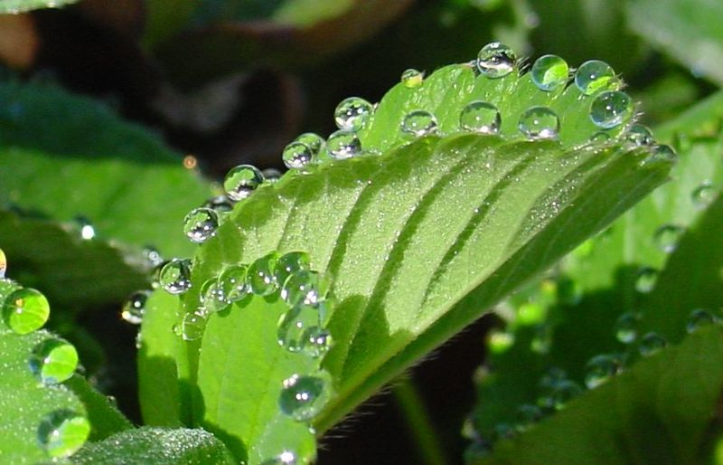
- Plants, which live in soils rich in calcium, can get rid of excess amounts of these elements by its accumulation in leaves which are finally shed.
- Carbon dioxide which results from respiration and oxygen obtained from photosynthesis are excreted through the stomata by diffusion.
- Excess water is cast, mainly through transpiration or guttation, where drops of water can be seen at the leaf tips of some plants like potatoes and tomatoes.
- This occurs in the early morning in spring. There is a special system for guttation which consists of one or many loose cells, opening by a water stoma called a hydathode which is open constantly day and night. Guttation water contains other substances which can therefore be deposited, when water evaporates rapidly.

Transpiration:
- The plant needs water, more in fact than an animal of equal weight.
- The animal can retain water in its body to be used again, while the plant uses about 90% of its water content to the outside.
- To illustrate, it is found that the plant absorbs 17 times more water daily than that taken in by a man of equal mass.
- It has also been found that one feddan of maize plant needs more than two million liters during its life.
- Great quantities of water are absorbed from the soil, mainly through the roots.
- Water is then transferred through the conductive tissues to the stems and leaves.
- At the same time the plant loses most of its water in a continuous manner. Water passes, in the form of vapor, through the moist cell walls of the mesophyll tissue, and evaporates into the intercellular spaces, where it diffuses out into the atmosphere through the stomata.
- The same process occurs in other cells that overlook other intercellular spaces in different plant tissues.
- Small quantities of water pass through the cuticle or through lenticels (opening that exist in the cork layer of the tree's stem) Loss of water therefore takes place over the total surface of the plant, exposed to air. The loss of water in the form of water vapor is called transpiration.
- More than 90% of the total is lost through the stomata and is called stomatal transpiration
- Water vapor which passes out directly through the epidermis covered with cuticle in the vegetative organs is called cuticular transpiration. It does not exceed 5% of the total amount of the lost water. Stems of woody plants lose small quantities of water vapor through the lenticels by lenticular transpiration.
- Stomata occur in plant leaves rather than in any other vegetative organ so most of the transpired water is lost through the leaves.
- In most of the dicotyledonous plants, the leaf blades are wide, flattened and contain a network of veins. The veins contain transporting cells which provide the mesophyll with water. The mesophyll tissue is characterized by the presence of intercellular spaces, which allow water to evaporate continuously through the cell walls.

Experiment to illustrate transpiration in plants:
- Take a potted leafy plant. Cover the soil surface and the surface of the pot with paraffin. Place the potted plant on a glass sheet under a dry bell-jar and wait for some time.
- Observation: Tiny droplets of water appear on the inside of the bell-jar, accumulate, they become bigger in size and run downwards on the wall of the bell-jar.
- Conclusion: Air inside the bell-jar receives water vapor from the plant which condenses. If you add the condensed liquid to anhydrous white copper sulphate, it becomes blue, confirming that the liquid is water. We can conclude that water passes from the exposed parts of the plants to the surrounding air.

Importance of transpiration for the plant:

The most important functions of transpiration are:
- The decrease of plant temperature.
- The ascent of water and salts form the soil.

Decrease of plant temperature:
A large amount of energy absorbed by the leaves is in the form of heat or is converted into heat inside the leaf tissues. This may cause a rise in the leaf temperature, especially on sunny, warm days. This rise in temperature harms the protoplasm and could lead to its death if transpiration did not decrease the plants' temperature through water loss.

Ascent of water and salts from the soil:
- The root cells contain cell sap with a concentration (of soluble organic and inorganic substances) higher than that of the soil solution. As a result, the soil water enters the root cells b osmosis. The osmotic pressure is sufficient to move water from the root hairs to the inner root tissues till it reaches the xylem vessels and tracheids. Water rises upwards through the xylem vessels of the stem, through vessels of the leaf (veins) and at the end it reaches the mesophyll cell sap, hence decreasing the ability of these cells to pull up more water .
- There are intercellular spaces full of air between the mesophyll cells, to which water vapor passes. As a result of the continuous loss of water from the mesophyll cells, their concentration increases, and so the ability to pull water upwards increases. This explains the so-called transpiration cycle and its role in the ascent of water.
- Osmotic pressure is only enough to move water through the plant stem for a short distance by what is known as root pressure.
- In some trees, water has to move through their vessels to a height reaching up to 125 meters, and therefore, a new theory was sought to explain the force which pushes water to such heights. This new theory is known as the adhesion and cohesion theory.

Experiment to show that water ascends through the xylem:
- fill a test tube with eosin solution. Carefully detach a small flowering plant (potted plant) with its roots. Immerse the plant roots in the eosin solution and close using a cotton wool plug at the opening of the tube. Keep the tube in a vertical position for few hours., What do you observe ?
Observation: The leaf petioles change to pink as well as the veins of the leaves and petals.
- Cut a thin, transverse section of the plant stem and examine under the microscope. (after placing it on a slide) What do you observe?
Observation: Xylem tissue is only stained by eosin
Conclusion: Pink coloration of petioles and petal veins indicates that eosin solution reaches these organs. This experiment shows:
- Water is absorbed b roots
- Water ascends through xylem tissue of the stem to the leaves.

Experiment to show the ascent of water by transpiration:
- Fill a small beaker with mercury. Fill a narrow tube with water and invert it in the beaker, so that its lower end becomes immersed in the mercury.
- Cut a leafy twig of a potted plant under water. Insert the lower tip of the twig in a cork plug through a hole. Fix the cork plug tightly with the twig in the upper opening of the tube and close it firmly with Vaseline. Mark the mercury level in the tube. Leave the apparatus in open air for a while. What do you observe?
Observation: Mercury rises in the tube.
Conclusion: The rise of mercury is due to transpiration pull, where the leafy twig loses water by evaporation, so water from the tube must rise to replace it. As a result, mercury rises up in the tube. This indicates that water loss by transpiration generates a pull to raise water upwards.

Questions on Excretion in plants

- Complete the following:
  - The plant utilizes the nitrogenous wastes in the synthesis of the required ………………..
  - The metabolism of plants is based mainly on ……………….. rather than ……………………,
  - Metabolic wastes such as ………………. salts and …………… are stored in the form of insoluble crystals in the cells of terrestrial plants, mainly in the cytoplasm or in the vacuoles. Since these crystals are insoluble they will cause no harm to the cells.
  - Many plants get rid of carbon dioxide and some mineral salts through their ………………...
  - Plants, which live in soils rich in calcium, can get rid of excess amounts of elements by its accumulation in …………………. which are finally shed.
  - Carbon dioxide which results from respiration and oxygen obtained from photosynthesis are excreted through the ………………. by diffusion.
  - Excess water is cast, mainly through ……………. or ……………………………,
  - ………………….. occurs in the early morning in spring.
  - There is a special system for guttation which consists of one or many loose cells, opening by a water stoma called a ………………………………
  - ………………………. is open constantly day and night. Guttation water contains other substances which can therefore be deposited, when water evaporates rapidly.

Transpiration:
- The plant needs water, more in fact than an animal of equal weight.
- The animal can retain water in its body to be used again, while the plant uses about 90% of its water content to the outside.
- To illustrate, it is found that the plant absorbs 17 times more water daily than that taken in by a man of equal mass.
- It has also been found that one feddan of maize plant needs more than two million liters during its life.
- Great quantities of water are absorbed from the soil, mainly through the roots.
- Water is then transferred through the conductive tissues to the stems and leaves.
- At the same time the plant loses most of its water in a continuous manner. Water passes, in the form of vapor, through the moist cell walls of the mesophyll tissue, and evaporates into the intercellular spaces, where it diffuses out into the atmosphere through the stomata.
- The same process occurs in other cells that overlook other intercellular spaces in different plant tissues.
- Small quantities of water pass through the cuticle or through lenticels (opening that exist in the cork layer of the tree's stem) Loss of water therefore takes place over the total surface of the plant, exposed to air. The loss of water in the form of water vapor is called transpiration.
- More than 90% of the total is lost through the stomata and is called stomatal transpiration
- Water vapor which passes out directly through the epidermis covered with cuticle in the vegetative organs is called cuticular transpiration. It does not exceed 5% of the total amount of the lost water. Stems of woody plants lose small quantities of water vapor through the lenticels by lenticular transpiration.
- Stomata occur in plant leaves rather than in any other vegetative organ so most of the transpired water is lost through the leaves.
- In most of the dicotyledonous plants, the leaf blades are wide, flattened and contain a network of veins. The veins contain transporting cells which provide the mesophyll with water. The mesophyll tissue is characterized by the presence of intercellular spaces, which allow water to evaporate continuously through the cell walls.

Experiment to illustrate transpiration in plants:
- Take a potted leafy plant. Cover the soil surface and the surface of the pot with paraffin. Place the potted plant on a glass sheet under a dry bell-jar and wait for some time.
- Observation: Tiny droplets of water appear on the inside of the bell-jar, accumulate, they become bigger in size and run downwards on the wall of the bell-jar.
- Conclusion: Air inside the bell-jar receives water vapor from the plant which condenses. If you add the condensed liquid to anhydrous white copper sulphate, it becomes blue, confirming that the liquid is water. We can conclude that water passes from the exposed parts of the plants to the surrounding air.

Importance of transpiration for the plant:

The most important functions of transpiration are:
- The decrease of plant temperature.
- The ascent of water and salts form the soil.

Decrease of plant temperature:
A large amount of energy absorbed by the leaves is in the form of heat or is converted into heat inside the leaf tissues. This may cause a rise in the leaf temperature, especially on sunny, warm days. This rise in temperature harms the protoplasm and could lead to its death if transpiration did not decrease the plants' temperature through water loss.

Ascent of water and salts from the soil:
- The root cells contain cell sap with a concentration (of soluble organic and inorganic substances) higher than that of the soil solution. As a result, the soil water enters the root cells b osmosis. The osmotic pressure is sufficient to move water from the root hairs to the inner root tissues till it reaches the xylem vessels and tracheids. Water rises upwards through the xylem vessels of the stem, through vessels of the leaf (veins) and at the end it reaches the mesophyll cell sap, hence decreasing the ability of these cells to pull up more water .
- There are intercellular spaces full of air between the mesophyll cells, to which water vapor passes. As a result of the continuous loss of water from the mesophyll cells, their concentration increases, and so the ability to pull water upwards increases. This explains the so-called transpiration cycle and its role in the ascent of water.
- Osmotic pressure is only enough to move water through the plant stem for a short distance by what is known as root pressure.
- In some trees, water has to move through their vessels to a height reaching up to 125 meters, and therefore, a new theory was sought to explain the force which pushes water to such heights. This new theory is known as the adhesion and cohesion theory.

Experiment to show that water ascends through the xylem:
- fill a test tube with eosin solution. Carefully detach a small flowering plant (potted plant) with its roots. Immerse the plant roots in the eosin solution and close using a cotton wool plug at the opening of the tube. Keep the tube in a vertical position for few hours., What do you observe ?
Observation: The leaf petioles change to pink as well as the veins of the leaves and petals.
- Cut a thin, transverse section of the plant stem and examine under the microscope. (after placing it on a slide) What do you observe?
Observation: Xylem tissue is only stained by eosin
Conclusion: Pink coloration of petioles and petal veins indicates that eosin solution reaches these organs. This experiment shows:
- Water is absorbed b roots
- Water ascends through xylem tissue of the stem to the leaves.

Experiment to show the ascent of water by transpiration:
- Fill a small beaker with mercury. Fill a narrow tube with water and invert it in the beaker, so that its lower end becomes immersed in the mercury.
- Cut a leafy twig of a potted plant under water. Insert the lower tip of the twig in a cork plug through a hole. Fix the cork plug tightly with the twig in the upper opening of the tube and close it firmly with Vaseline. Mark the mercury level in the tube. Leave the apparatus in open air for a while. What do you observe?
Observation: Mercury rises in the tube.
Conclusion: The rise of mercury is due to transpiration pull, where the leafy twig loses water by evaporation, so water from the tube must rise to replace it. As a result, mercury rises up in the tube. This indicates that water loss by transpiration generates a pull to raise water upwards.

