

New Al-rayyan Independent Secondary School for boys. New Al-rayyan Independent Secondary School for boys. New Al-rayyan Independent Secondary School for boys. New Al-rayyan Independent Secondary School for boys. New Al-rayyan Independent Secondary School for boys. New Al-rayyan Independent Secondary School for boys. New Al-rayyan Independent Secondary School for boys. New Al-rayyan Independent Secondary School for boys. New Al-rayyan Independent Secondary School for boys. New Al-rayyan Independent Secondary School for boys. New Al-rayyan Independent Secondary School for boys. New Al-rayyan Independent Secondary School for boys. New Al-rayyan Independent Secondary School for boys. New Al-rayyan Independent Secondary School for boys. New Al-rayyan Independent Secondary School for boys. New Al-rayyan Independent Secondary School for boys. New Al-rayyan Independent Secondary School for boys. New Al-rayyan Independent Secondary School for boys. New Al-rayyan Independent Secondary School for boys. New Al-rayyan Independent Secondary School for boys..

|  |
| --- |
| Al-Rayyan Independent Secondary School  Biology department  2009/2010  Enrichment sheet  Chapter 1 Biologically important molecules. |

Qatar Biology Standards

**Grade 10 Advanced Biology**





## Biology Standards covered in this unit:

By the end of Grade 10, students know the composition and structure of glucose, amino acids, glycerol, fatty acids, triglycerides, phospholipids, chlorophyll and haemoglobin. They know that monosaccharides and amino acids are the monomers of other carbohydrates and proteins, respectively. They describe the primary, secondary and tertiary structure of proteins. They understand the relationship between the structure and the function and properties of biological molecules. They recognise test results for protein, sugar and starch, and know the purpose of chromatography and electrophoresis. They know the structure of prokaryote and eukaryote cells.

### Students should:

#### 5 Describe the composition and molecular structure of some biologically important molecules

5.1 Describe the composition and molecular structure of glucose, amino acids, glycerol, fatty acids, triglycerides, phospholipids, chlorophyll and haemoglobin.

Study three-dimensional molecular models.

Make simple molecular models.

5.2 Recognise that monosaccharides and amino acids are monomers for other carbohydrates (e.g. starch and cellulose) and proteins (e.g. enzymes), respectively.

Carry out chemical tests for carbohydrates.

Separate amino acids by chromatography.

5.3 Describe the primary, secondary and tertiary structure of proteins.

Study three-dimensional molecular models.

#### 6 Relate the properties of some biologically important molecules to their size and structure

6.1 Know that smaller molecules are soluble, can be transported and are mostly involved in metabolism, while large molecules tend to have storage (e.g. starch), structural (e.g. cellulose) and informational (e.g. DNA) roles.

Determine the solubility of compounds with large and small molecules.

Given the relative size of molecules, carry out matching exercises to relate molecules to functions.

6.2 Recognise the results of tests for proteins, sugars and starch.

Carry out standard tests for proteins, sugars and starch.

Identify biological molecules from electrophoresis and/or chromatography data.

6.3 Know that biological molecules can be separated and identified by chromatography and electrophoresis.

Use chromatography and electrophoresis to separate mixtures of compounds.

Identify biological molecules from electrophoresis and/or chromatography data.

Chapter1: Biologically important molecules.

# Atoms:

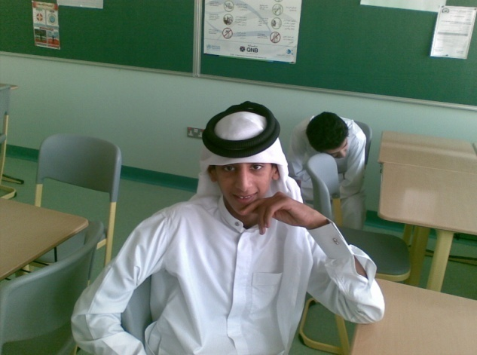They are very small but there are three particles that make up an atom:

No. of protons = No. of electrons = **Atomic No**. and is written down to the left like 8O, 1H, Etc.

1. Positive **protons.**
2. Not charged **neutrons.**
3. Negative **electrons**

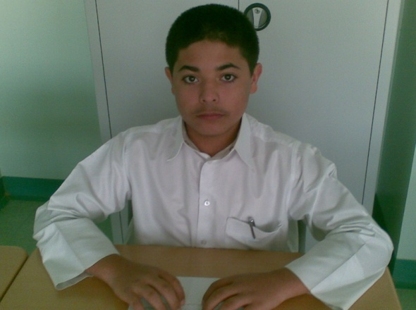**A molecule** consists of 2 or more atoms joined together chemically.

No. of neutrons + No. of protons are called Mass No. and is written up to the left like 16O, 2H.etc.

**Ions** are charged particles (when an atom or a group of atoms gain or lose electrons they form ions)

Some periodic tables write mass No. down & atomic above the bigger one is the mass No and the smaller is the atomic.

**Isotopes**: Atoms of the same atomic No. and different mass No.

**Acid**: A substance that gives Hydrogen ions when dissolve in water and has pH less than 7.

**Base:** A substance that gives Hydroxyl ions (OH) when dissolves in water and has pH more than7.

# Carbohydrates:

* Composed of: Carbon, Hydrogen and Oxygen (H and O are in the same ratio of water H2O).

What is the importance of carbohydrates?

* 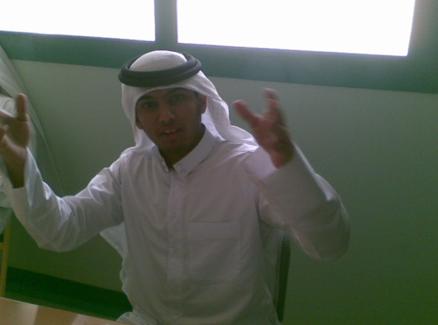The subunit (CH2O) can be repeated (CH2O) n many times to form different molecules.
* There are three types of carbohydrates:
  1. Monosaccharide (monomer)
  2. Disaccharides (polymer)
  3. Polysaccharides (polymer)

Carbohydrates are important in: Storing energy and supporting plant cell wall and even insect skeleton.

1. Monosaccharides:

* Naming monosaccharide depends on No. of carbon atoms:
  1. 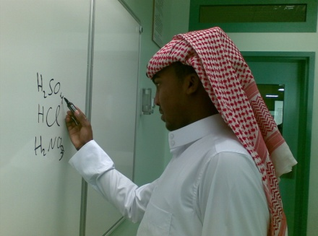3 carbons = trioses (glyceraldehydes)
  2. 5 carbons= pentoses (Ribose and deoxiribose)
  3. 6 carbons= hexoses (Glucose, fructose and galactose).
* Monosacharides usually exist as ring structure when they dissolve in water.
* Isomerism is having 2 or more molecules of the same chemical formula but they have different arrangement of atoms so we call them structural isomers.
* 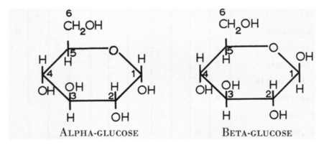In the next diagram you’ll find isomers can you tell the difference?

1. Disacharides:

Removing water is called dehydration ( this is the reaction that joins 2 monosaccharides to form 1 disacharide) and adding water is called hydrolysis (this is the reaction that breaks 1 disaccharide to form 2 monosacharide)

1. 2 Monosaccharides are joined together to form a disaccharide.
2. This reaction releases water so it is called a condensation reaction
3. 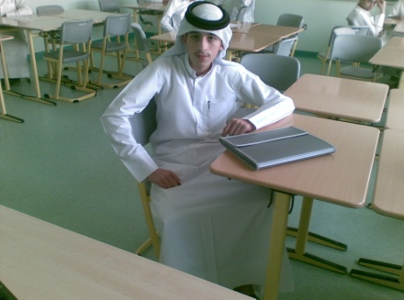The link between the monosaccharide rings as called a …. .glycosidic bond.
4. The 2 monosacharides may be:
   1. The same (2 glucoses makes 1 maltose)
   2. 2 different monosacharides :
      1. (Glucose + fructose = Sucrose) found in sugar cane.
      2. (Glucose + Galactose = Lactose) found in milk.
5. Polysacharides:
6. Formed between hundreds of monosaccharides to form a chain (branched or un-branched )

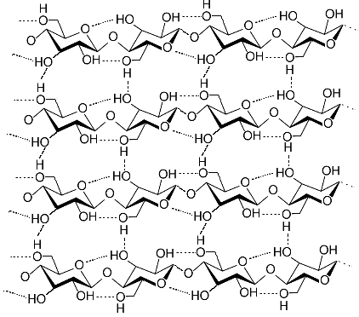

1. They are held together by glycosidic bonds. (do you remember dehydration).
2. They are not soluble in water.
3. They are not sweet in taste.
4. Storage polysaccharides are folded to save space. (Compact).

Examples:

* 1. **Starch:** 
     1. It is a polymer made of many α glucose linked together (Do you remember the name of the bond?)
     2. Actually it also contains Amylose and Amylopectin
  2. **Glycogen:**

1. Sometimes it is called animal starch.
2. In humans it is stored in liver and skeletal muscles.
3. Liver glycogen may be converted to glucose if needed.
   1. 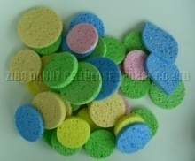**Cellulose:**
4. Structural polysaccharide made up of thousands of beta glucose.
5. Humans can’t digest cellulose but cows and horses can.
6. We use cellulose in many industries.
   1. **Chitin:**

Search the web for chitin and make a small article about it.

# Lipids:

* 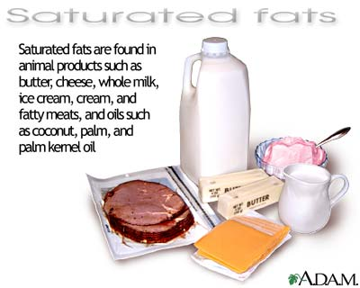They include oils and fats.
* Like carbohydrates they are made of carbon, hydrogen and oxygen.(but less oxygen).
* They are non-polar compounds (soluble in water).
* They dissolve in non-polar solvents like ether and alcohol.
* At room temp. fats are solid and oils are liquids
* Triglycerides = glycerol + fatty acid. (Glycerol always the same but different fatty acids).
* Fatty acid is a carboxyl group (-COOH)attached to a long tail of hydrocarbon.
* 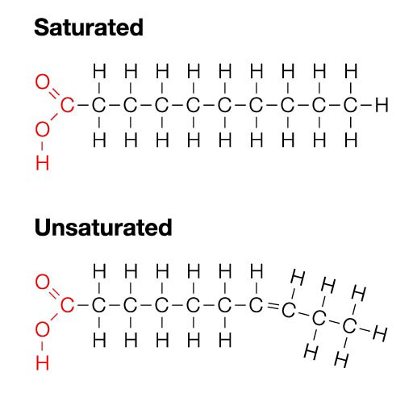What makes differences between fatty acids?

1. How long the hydrocarbon chain is?
2. How saturated the molecule is?

* Saturated fatty acids have only C-C bond.
* Unsaturated fatty acids have at least one C=C bond.

# Triglycerides:

1. Composed of one glycerol and 3 fatty acids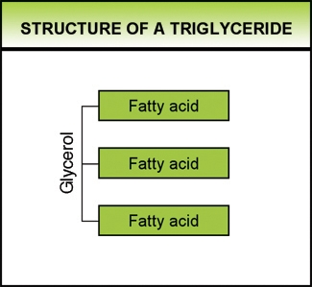
2. When oxidized they release more energy than equal amount of carbohydrates.
3. They also release a lot of water during oxidation
4. The hump of camel is made of fats.

# Phospholipids:

1. 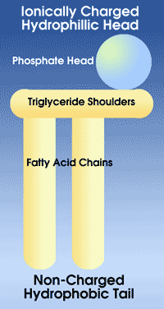They are similar to triglyceride but one of the fatty acids is replaced by a phosphate group.
2. The lipid part is non-polar (Hydrophobic)
3. The phosphate part is polar (hydrophilic)

# Proteins:

1. Protein makes up most of the cell (after water )
2. Activities of proteins:

|  |  |  |  |
| --- | --- | --- | --- |
| No. | Protein. | Activity(function) | Example |
| 1 | Enzymes | Catalyze chemical reactions | Amylase |
| 2 | Carrier proteins | Transport | NAD & FAD |
| 3 | Antibodies | Defend | Penicillin |
| 4 | Structural proteins | Support | Lignin |
| 5 | Hormones | Transmit information | Adrenalin |
| 6 | Transport proteins | Carry | Haemoglobin |
| 7 | Contractile proteins | Make muscles contract | Actin and myocin |

1. Structure of protein:
   1. 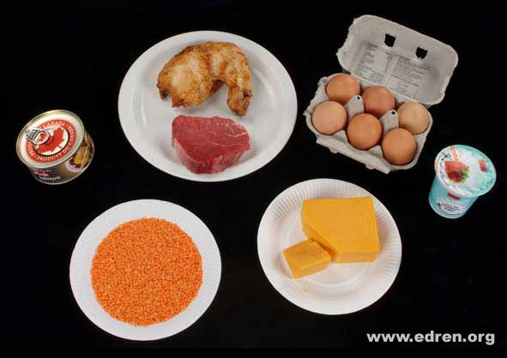Mainly carbon, Oxygen, Hydrogen in addition to Nitrogen.
   2. Some of them contain sulphur and phosphorus.
   3. They are polymers of amino acids
   4. There are 20 amino acids but thousands of proteins.
   5. The function of protein depends on its shape.
   6. The shape depends on the sequence of amino acids
2. Amino acids:
   1. 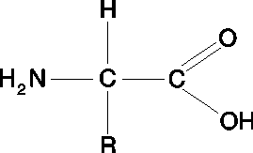They are composed of:
      1. Amino group -NH2 at one end of the molecule.
      2. Carboxyl group –COOH at the other end.
      3. R group differs from one amino acid to the other.
      4. They are amphoteric (can act like bas or acid) due to the 2 groups they have.
      5. 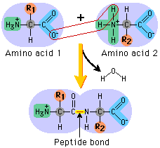They act as buffer due to that property.
3. The peptide bond:
   * 1. Amino acids are monomers of proteins
     2. They combine together to form polypeptide chain
     3. Condensation reaction happens between amino group of one amino acid and carboxyl group of the other.(peptide bond).
     4. A poly peptide chain may contain hundreds of amino acids.
4. 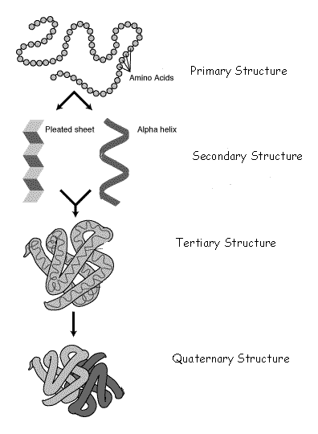Protein structure:
   1. **Primary structure**: the sequence of amino acids e.g NH2-Leucin-valine-cystein-arginin-COOH (20 amino acids are making over 100000 known proteins)
   2. **Secondary structure**:The chain form a helices and plated sheets held together by a hydrogen bonds.
   3. **Tertiary structure**:the 3d shape when the helix twists and folds around itself.
   4. **Quarternary structure**: the linking together of a number of a poly peptide chain.(Hemoglobin contains 4 separate kinds of polypeptide chains).

# Haemoglobin:

1. Structure of Haemoglobin :
   1. Glubiolar protein (compact)
   2. It picks Oxygen from the lungs to form oxyhaemoglobin
   3. Oxyhaemoglobin gives up its oxygen to the tissues and return back is haemoglubin to the lungs to repeat his job.
   4. It consists of 4 polypeptide chains.
   5. Disulphide Bridge holds the chains together.
   6. At the center of each chain is an iron containing group called haem
   7. Each iron ion can combine with one molecule ofOxygen
   8. This is why each haemoglobin molecule can pick up 4 molecules of Oxygen.

# Chlorophyll

1. 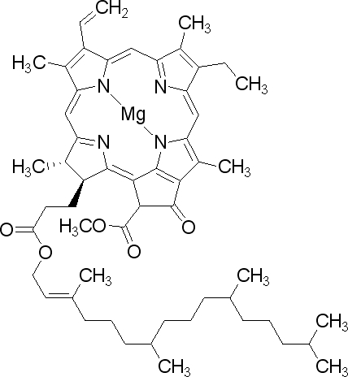 *Chlorophyll is a family of photoreceptive molecules used by cyanobacteria, algae and plants to perform photosynthesis.*
2. *As can be seen on the left, chlorophyll molecules are largely made of carbon and hydrogen, with some nitrogen-containing molecules surrounding a central magnesium atom.*
3. *There are several kinds of chlorophyll, the dominant one is Chlorophyll* a*. Chlorophyll*a*is used by cyanobacteria, algae and plants, often with chlorophyll*b *alongside it.  Chlorophyll*c*,*d*and bacteriochlorophyll are sometimes accessory pigments, transferring their energy to the primary molecules.*
4. *Chlorophyll functions by absorbing light, which excites the electrons within the molecule (kind of like a solar cell) and this produces a series of complex chemical reactions.*
5. *This all ends with carbon dioxide being reacted with water to create organic compounds and free oxygen.*
6. *Cyanobacteria were the first lifeforms on Earth to use chlorophyll and it is believed that chloroplasts, the structures in cells that house chlorophyll, originated by a sort of symbiotic merger of eukaryotic cells and cyanobacteria.*

