General questions and activities

Chapter1: Biologically important molecules.

Atoms:
- Using the following data in the periodic table COMPLETE the table below:
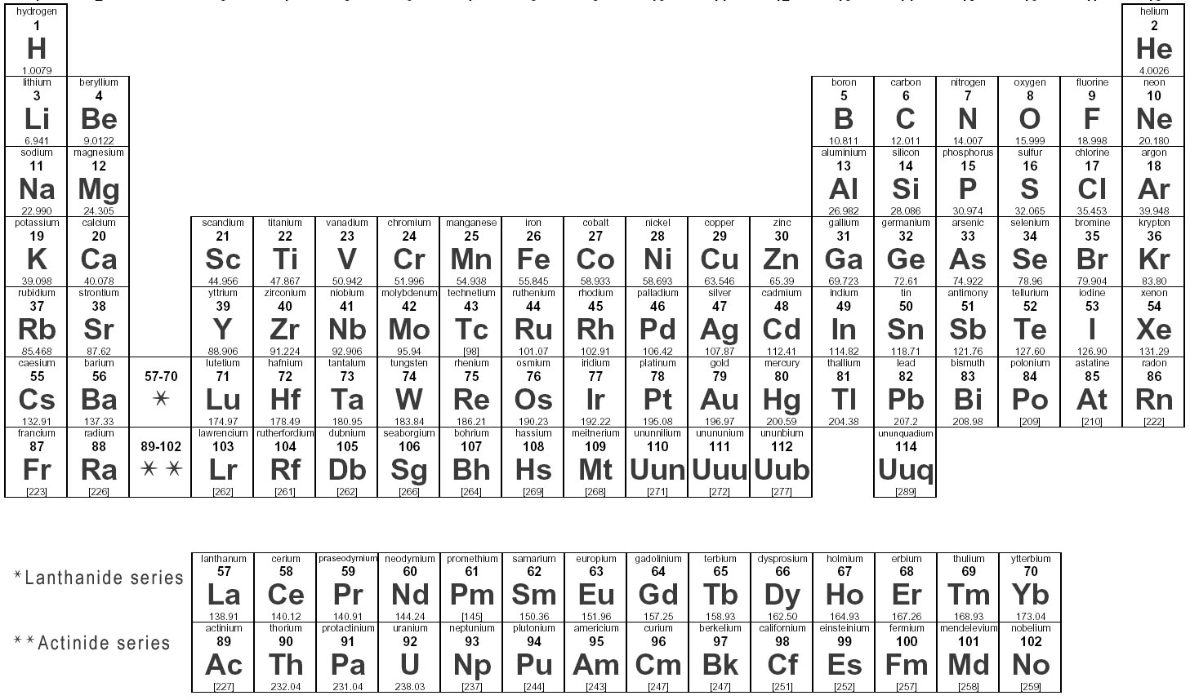
Element | Mass No. | Atomic No. | No. of electrons. | No. of protons | No of neutrons.
H
Li
Na
K
Ba
N
F

- Connect column A to the suitable respond of column B:
Column A | Column B
- Positive part of an atom | - Nucleus
- Negative part of an atom | - Proton
- Neutral part of an atom | - Electron
- Found in the middle of the atom and contains both protons and neutrons. | - Neutron

- What do you know about
- Atom
- Molecule
- Proton
- Neutron
- Electron
- Acid
- Base
- Atomic number
- Mass number
- Ion
- Isotop
- Complete the following statements:
  - Carbohydrates are composed of …………… , …………………… and ……………………….
  - The subunit ………………… can be repeated ………………… many times to form different molecules.
  - Carbohydrates are important in ……………………………………. And ………………………………………

- Look at the figure and mention the name of the compound:
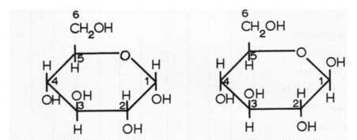

………………………………………
………………………………………

- What is the name of each of the following sugars:
A-

B-

C-
- Write the chemical formula of each of the following:
  - Trioses
  - Pentoses
  - Hexoses
- Complete the following statements:
  - Removing water is called …………………………………………………… ( this is the reaction that joins 2 monosaccharides to form 1 disacharide) and adding water is called ……………………………………………………. (this is the reaction that breaks 1 disaccharide to form 2 monosacharide)
  - 2 Monosaccharides are joined together to form a ………………………...
  - If a reaction releases water it will be called a …………………………….. reaction
  - The link between the monosaccharide rings as called a …. ………………………… bond.
  - 2 glucoses makes 1 ………………………
  - (Glucose + fructose = …………………..) found in ……………………..
  - (Glucose + Galactose = …………………………….) found in.

